**Puget Sound Rockfish Worksheet**

1. **Questions**
   * 1. How big is the rockfish population in the Puget Sound?
     2. Which type of habitat do rockfish use? Low relief or high relief?
2. **Hypothesis**

I think there will be more rockfish in $\frac{low relief habitat}{high relief habitat}$ (circle one) because:

1. **Methods**

Underwater video footage was collected in Puget Sound during summer 2015. Footage was collected using a Remotely Operated Vehicle (Seaeye Falcon) equipped with a camera. Footage was collected at different sites throughout Puget Sound.

1. **Observe and record**

*Observe* 1.5 minute of video footage from two sites. Use the ‘Data Collection’ sheet to *record* your observations of rockfish.





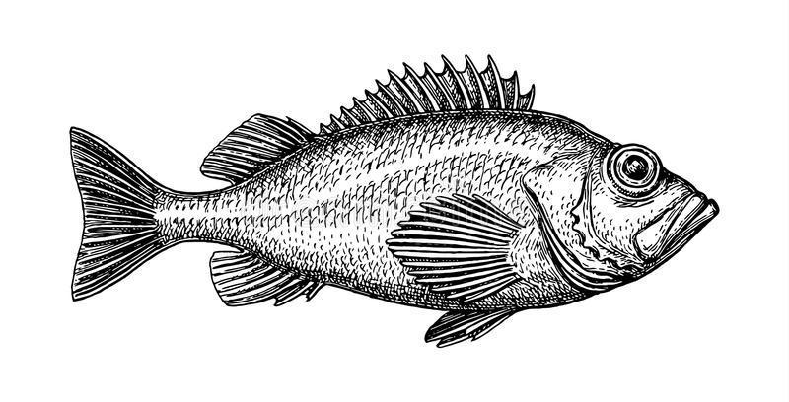

Did you see more rockfish in high relief or low relief habitat? ___________